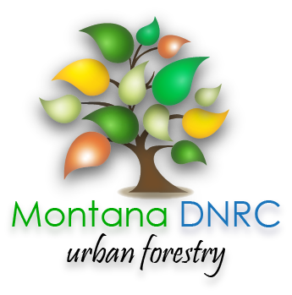 |  |  | MONTANA URBAN & COMMUNITY FORESTRY AWARD  PROJECT REIMBURSEMENT CHECK LIST
REPORTING INFORMATION:
Please use the following checklist to ensure all the required items and supporting documentation are submitted with your Project Report Form. Failure to provide required items may significantly delay the timing or the ability of the DNRC to disburse funds.
 | Attach this UCF Project Report Form as cover page of reimbursement package
 | Include Proof of Payment for all expenditures - both matching and requested expenses for reimbursement
 | (proof may be established with itemized receipts, paid vendor invoice, financial reports,
 | payroll records, copies of checks, bank statements, or similar)
 | Ensure all purchases and activities occur BEFORE grant expiration date
 | Ensure any match requirements are met and well documented (Program Development grants require
 | 100% match, other grants may vary)
 | Provide list of participant names for any claimed time for meetings, volunteers, workshops, etc.
 | Attach Bid Verification Form (for purchases or services of $2,000 or more)
 | Attach copy of completed project inspection form signed by designated DNRC urban forester
 | Attach any additional requirements mentioned in grant agreement (i.e. maintenance plan, etc.)
 | Attach brief narrative summary of work completed (describing project, positive outcomes, challenges, etc.)
 | Include photos or articles related to the project, if applicable
 | Provide sample of finished product, if applicable (i.e. copy of inventory, management plan, etc.)
Name of Representative Submitting Report:
Email address for questions or concerns:
Signature: |  |  |  |  | Date:

MONTANA URBAN & COMMUNITY FORESTRY AWARD
PROJECT REPORT FORM

Agreement #: |  | Award Amount:

Community: |  | Federal Tax Identification Number:

Payment Mailing Address:

Total Reimbursement Amount Requested; all receipts must be included:

Total Matching Amount Claimed (b) +(c); all receipts must be included:

Total number of volunteers involved in all aspects of the project:

Total volunteer hours:

Number of trees planted:

REPORTING INFORMATION:
Program Development Grants require a 100% match in addition to the grant amount.
(Example: $1,000 grant award x 100% match requirement = $1,000 match).
Supporting documentation such as receipts and invoices are required for all
reimbursable and matching expenses claimed.
As per the award agreement, communities will be reimbursed for actual costs not to exceed the grant amount. If receipts total more than the specified grant amount, the community will be responsible for all additional costs.
Please review the checklist before submitting this request.

Type of  Project Expenses* | Hourly Rate or Piece Rate (per each) | Quantity | (a)  Grant  Funds  Requested | (b)  Applicant Cash Match | (c)  $ Value of Donated & In-Kind | Total  (a) + (b) + (c)
Page 1 Subtotal | - | -
Page 2 Subtotal  (if applicable) | - | -
Grand Total (page 1 & 2) | - | -

Please mail this report, receipts, and all additional documentation to:
Montana DNRC, Urban and Community Forestry Program,
2705 Spurgin Road, Missoula, Montana 59804-3199

MONTANA URBAN & COMMUNITY FORESTRY GRANT
PROJECT REPORT FORM
Agreement #:

Type of  Project Expenses* | Hourly Rate or Piece Rate (per each) | Quantity | (a)  Grant  Funds  Requested | (b)  Applicant Cash Match | (c)  $ Value of Donated & In-Kind | Total  (a) + (b) + (c)
Column Totals | - | -

