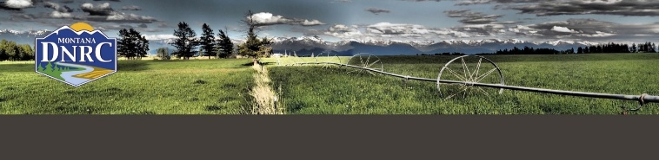

Stakeholder Working Group

**Comprehensive Water Review**

**Change, Mitigation, and Exceptions**

**Stakeholder Working Group**

**Meeting Agenda**

**Thursday, September 10th, 2024**

9:00AM to 4:00PM

**Montana League of Cities (Location Change)**

700 W Custer Ave

Helena, MT

**Meeting Objectives**

* Review, discuss, and vote on the bill concepts and recommendations
* Share process on next steps to finalizing bill drafts for legislative review

*\*Agenda timing is subject to change based on the needs/requests of SWG members during the meeting.*

*\*Public Participation will happen throughout the meeting as appropriate within the SWG discussions. We will also hold a specific time for public comment. If the public has a particular comment to share where we did not have time for everyone to share or that is not relevant to the meeting discussion, please share via* [*Dnrwaterstakeholders@mt.gov*](mailto:Dnrwaterstakeholders@mt.gov)

**Agenda**

**9:00 AM** **Welcome, Agenda Overview, and Introductions**

**9:10 AM** **Voting – Define**

**9:15 AM** **Exempt Well Policy**

**10:15 AM Break**

**10:30 AM** **Provisional Permits and Changes Reconciliation**

**11:00 AM** **Division Court**

**11:30 AM Funding Packages**

**Noon** **Lunch**

**12:30 PM Waiver of Adverse Effect**

**1:00 PM Agency Coordination and Notice of Intent for Exempt Wells**

**1:45 PM Break**

**2:00 PM Streamlined Change Process**

**3:00 PM Recommendations and Next Steps**

**3:30 PM** **Public Participation**

As usual, we will do our best to incorporate public questions and comments throughout the discussion.If unable, we will designate this time to do so.

**4:00 PM Adjourn**