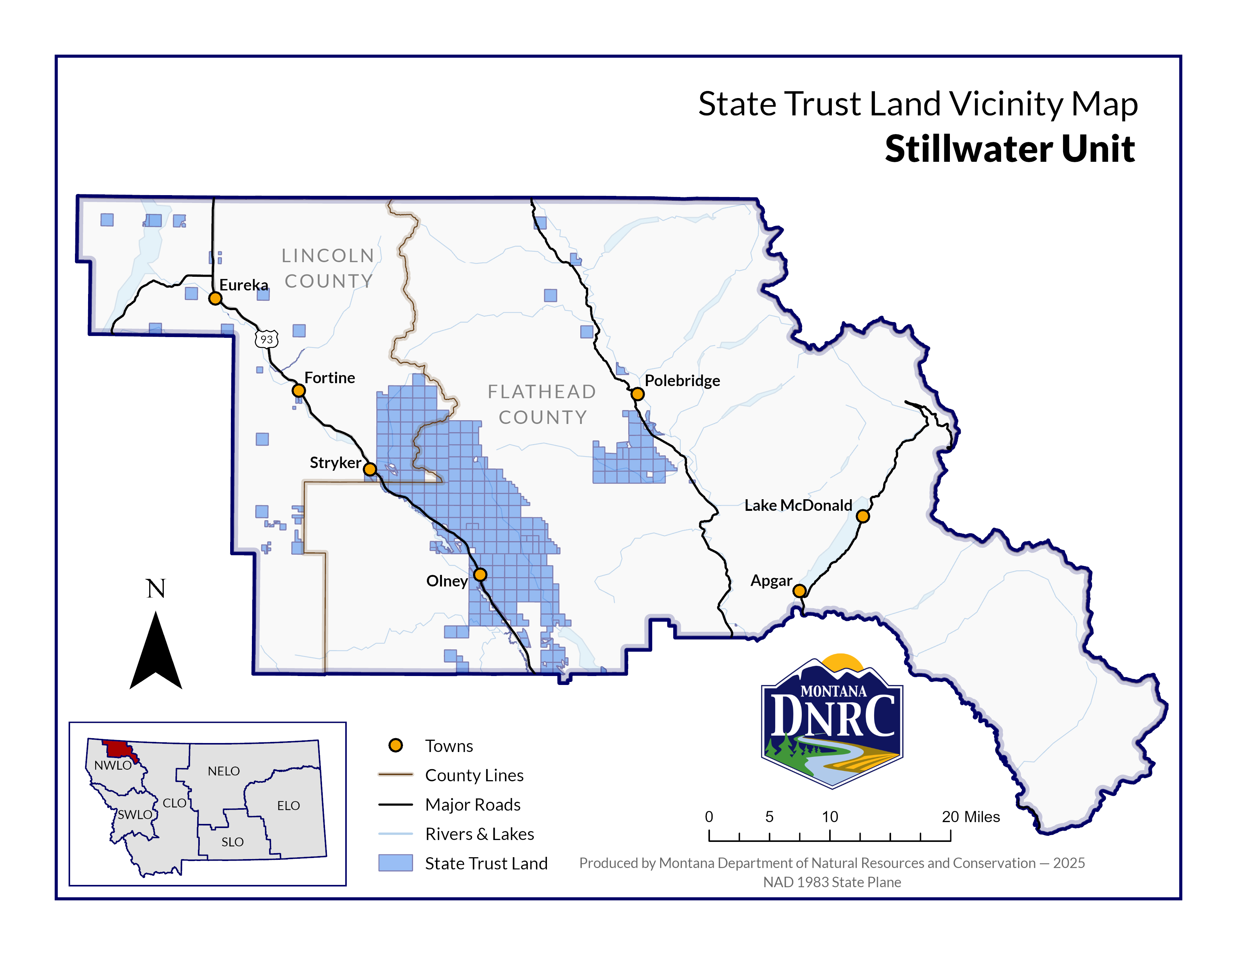

**Sections: 29, 31, 32, and 33**

**Township: 35N**

**Range: 24W**

**County:Lincoln**

*Chopax Timber Sale*