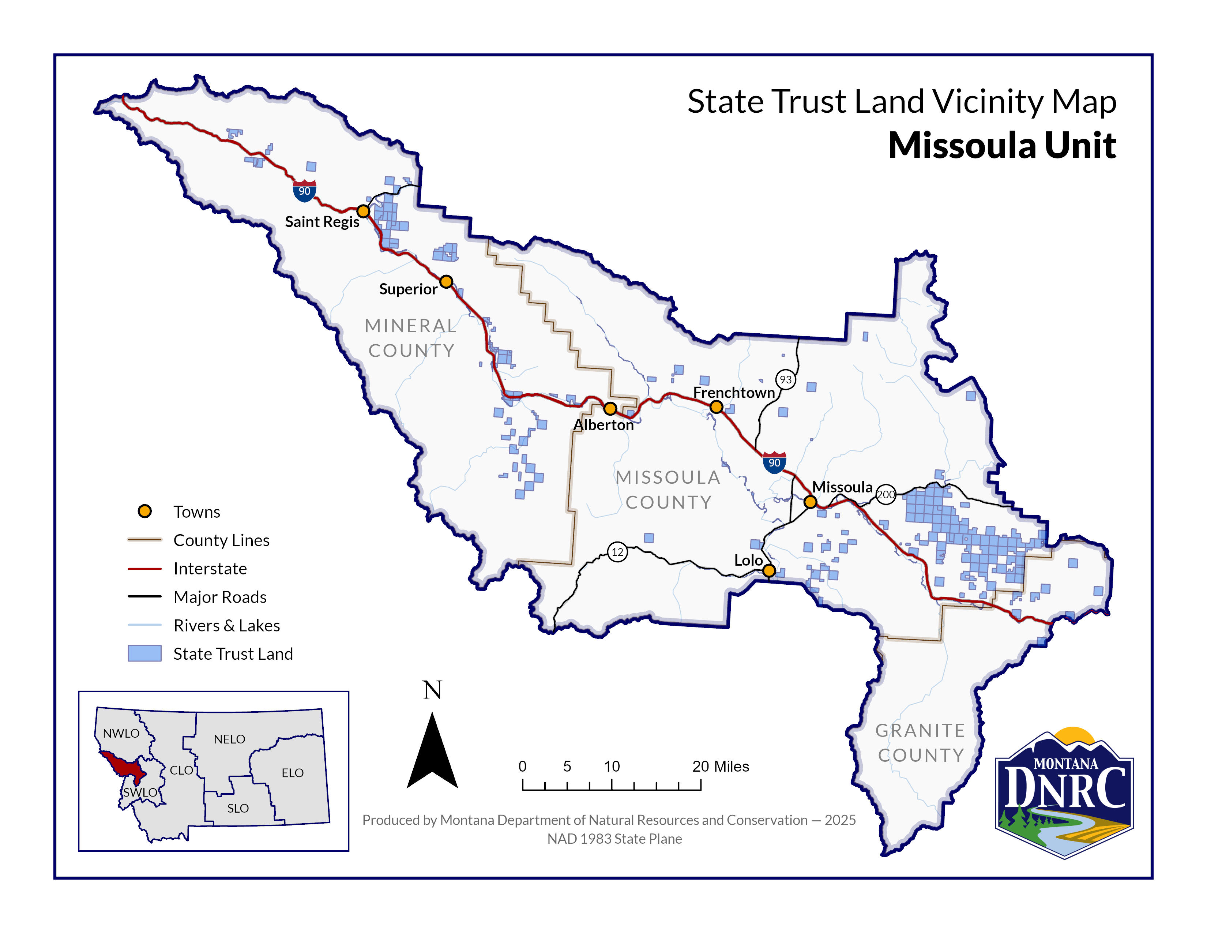

**Section 4 T17N R27W**

**Sections 27, 33, 34, 35**

**T18N R27W**

**County: Mineral**

*Four Score Timber Sale*