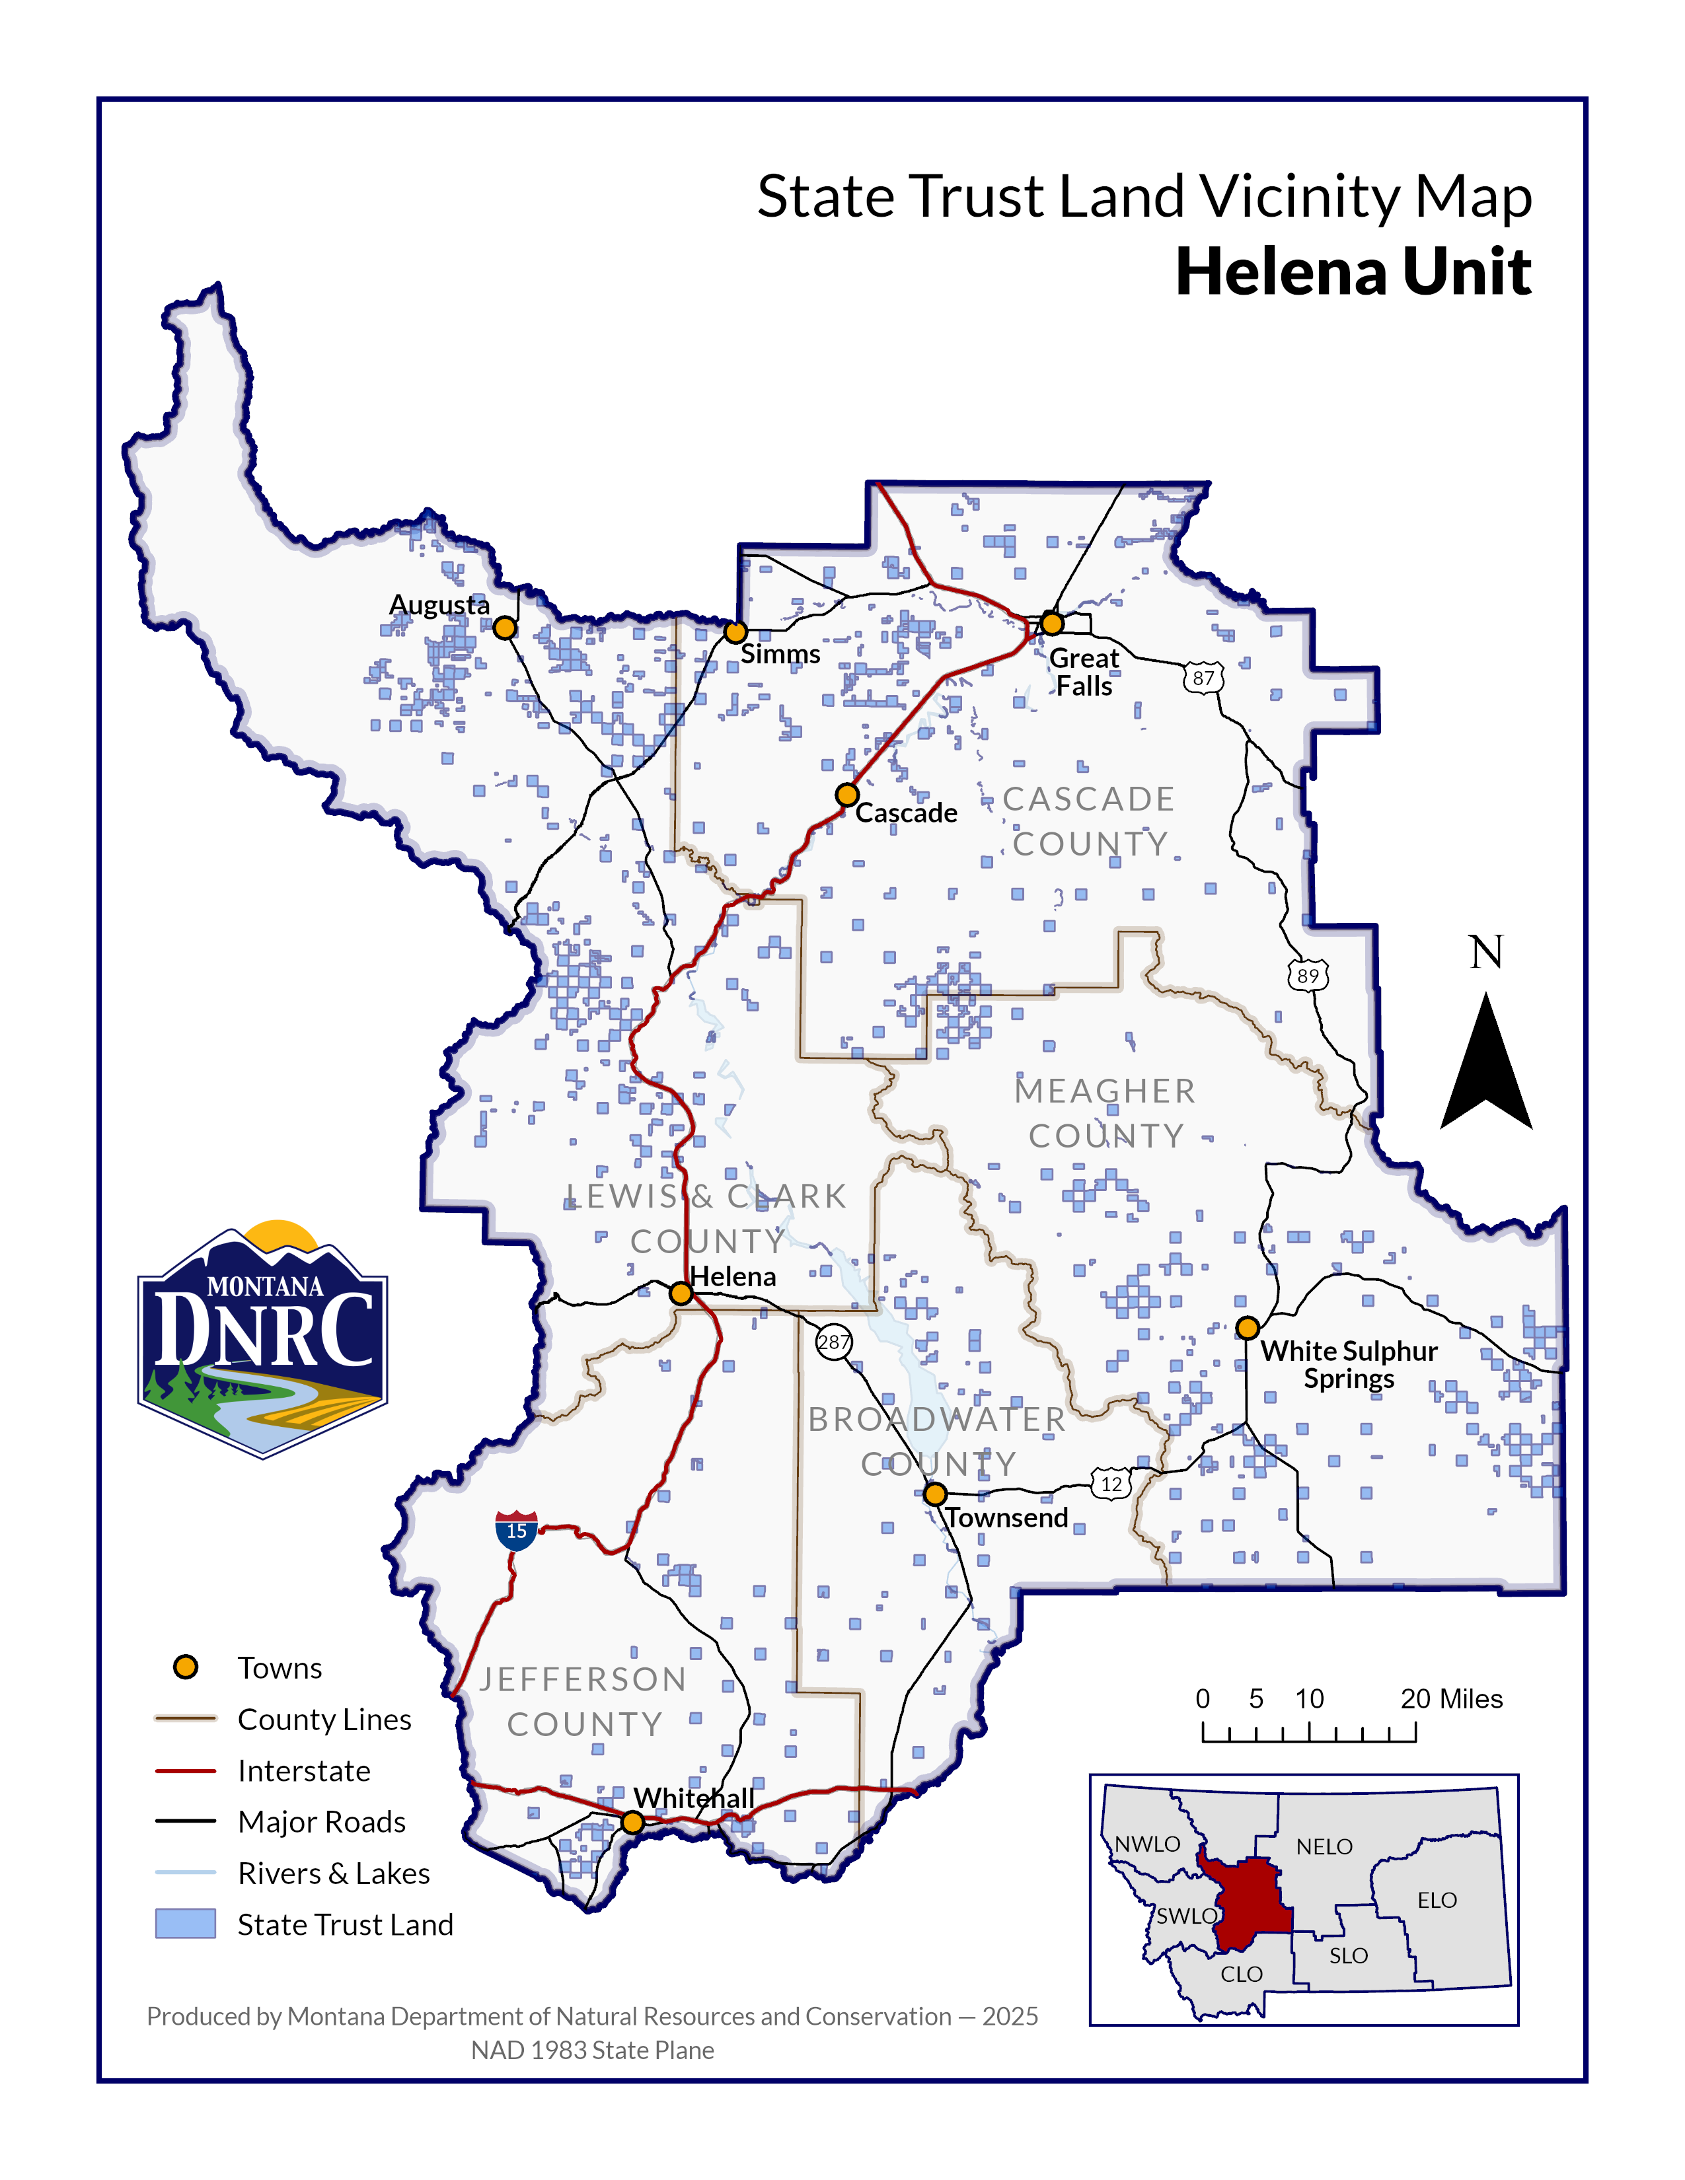
Comers Butte Timber Permit
Section: 16
Township: 19N
Range: 8E

County: Cascade

