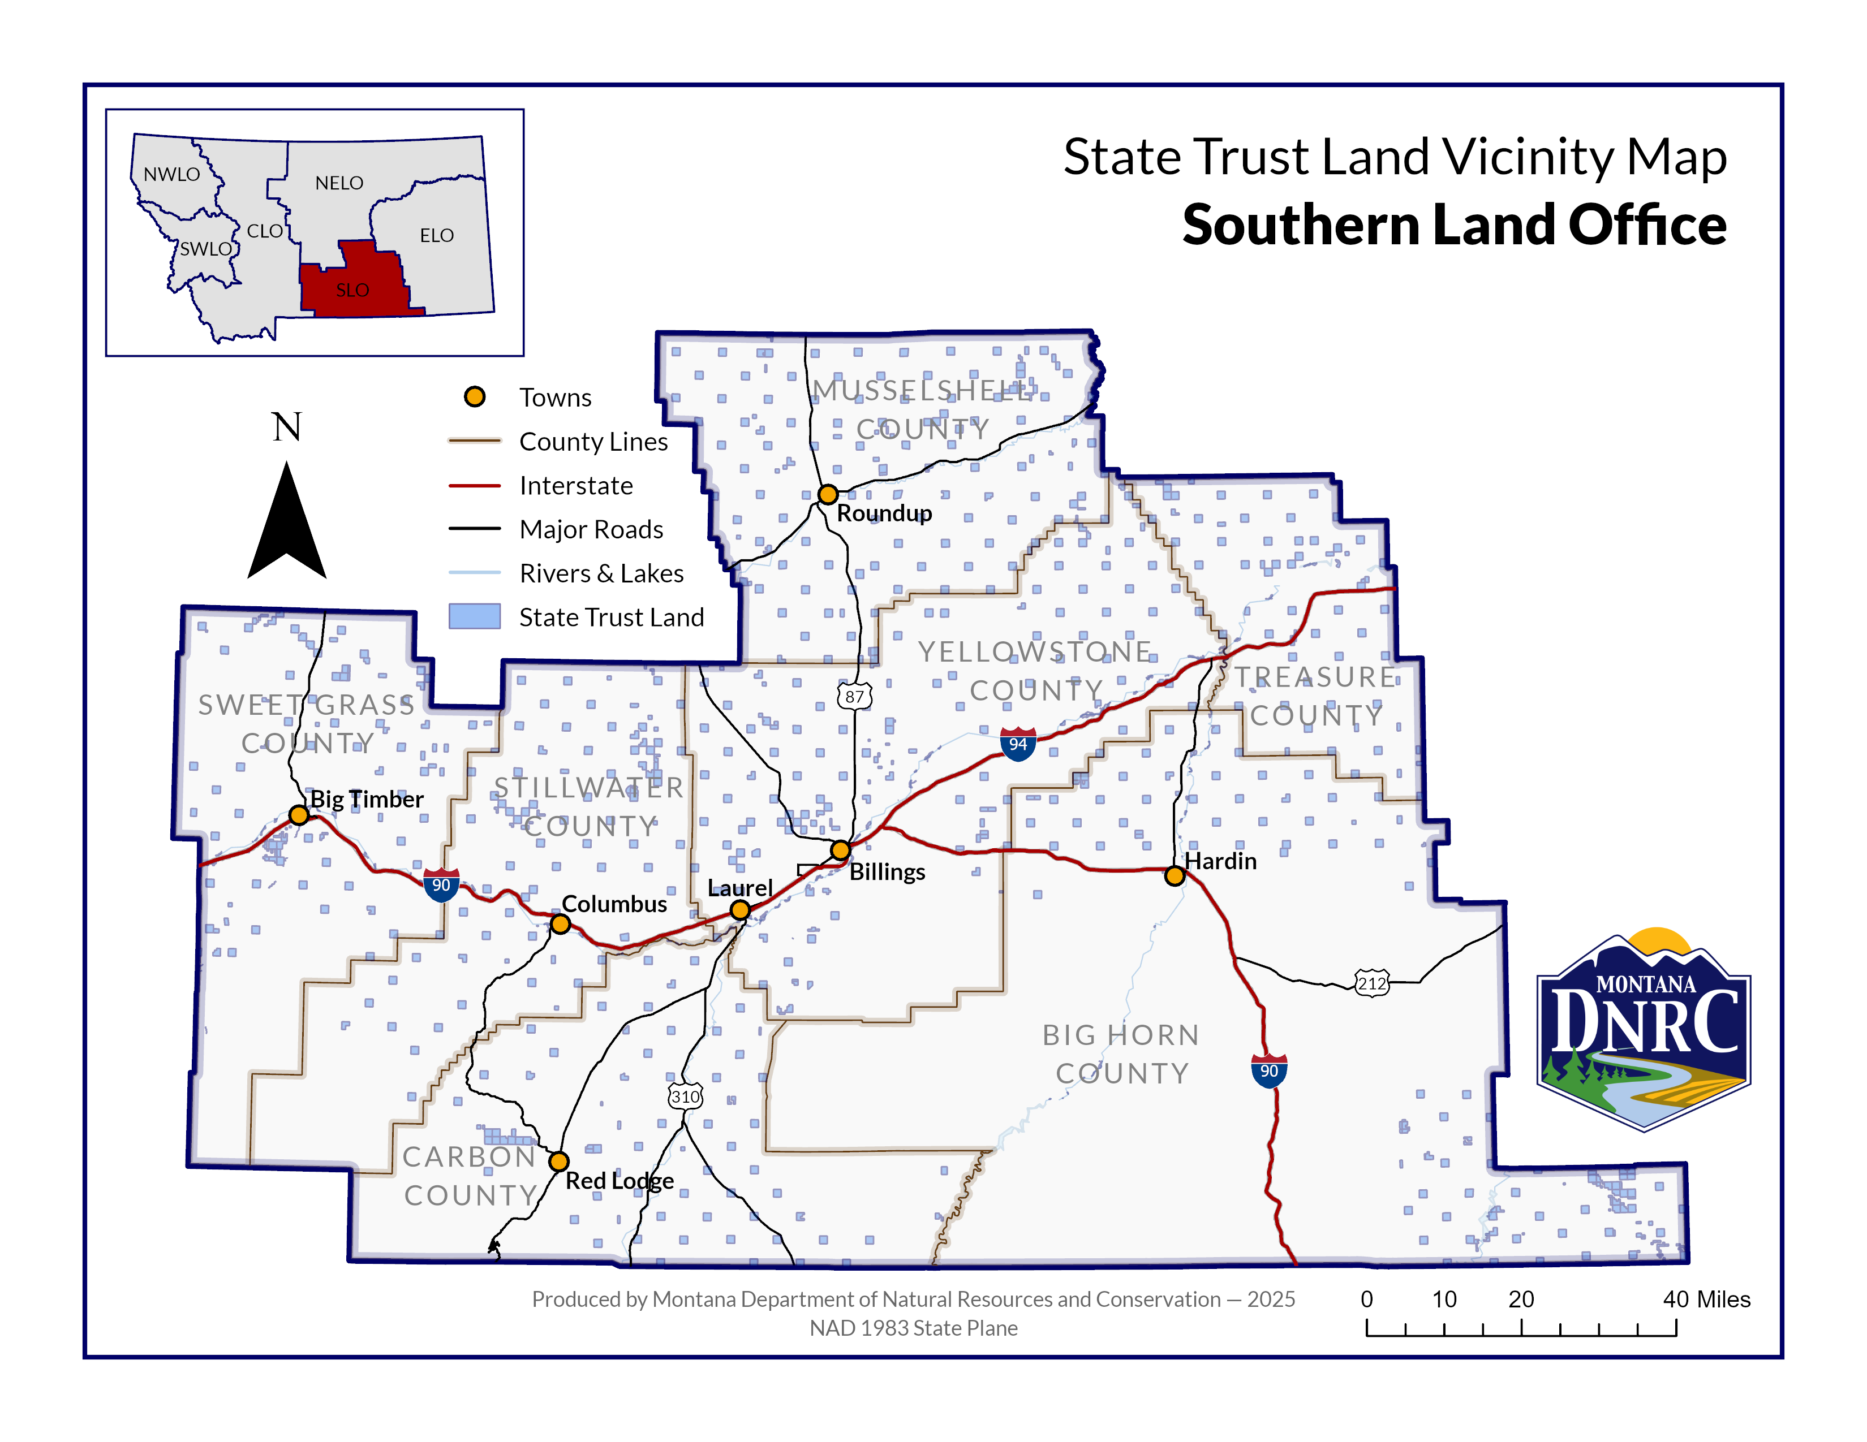
Section:36
Township: 6N
Range: 24E

County: Musselshell
East Fork Dean Creek Permit

