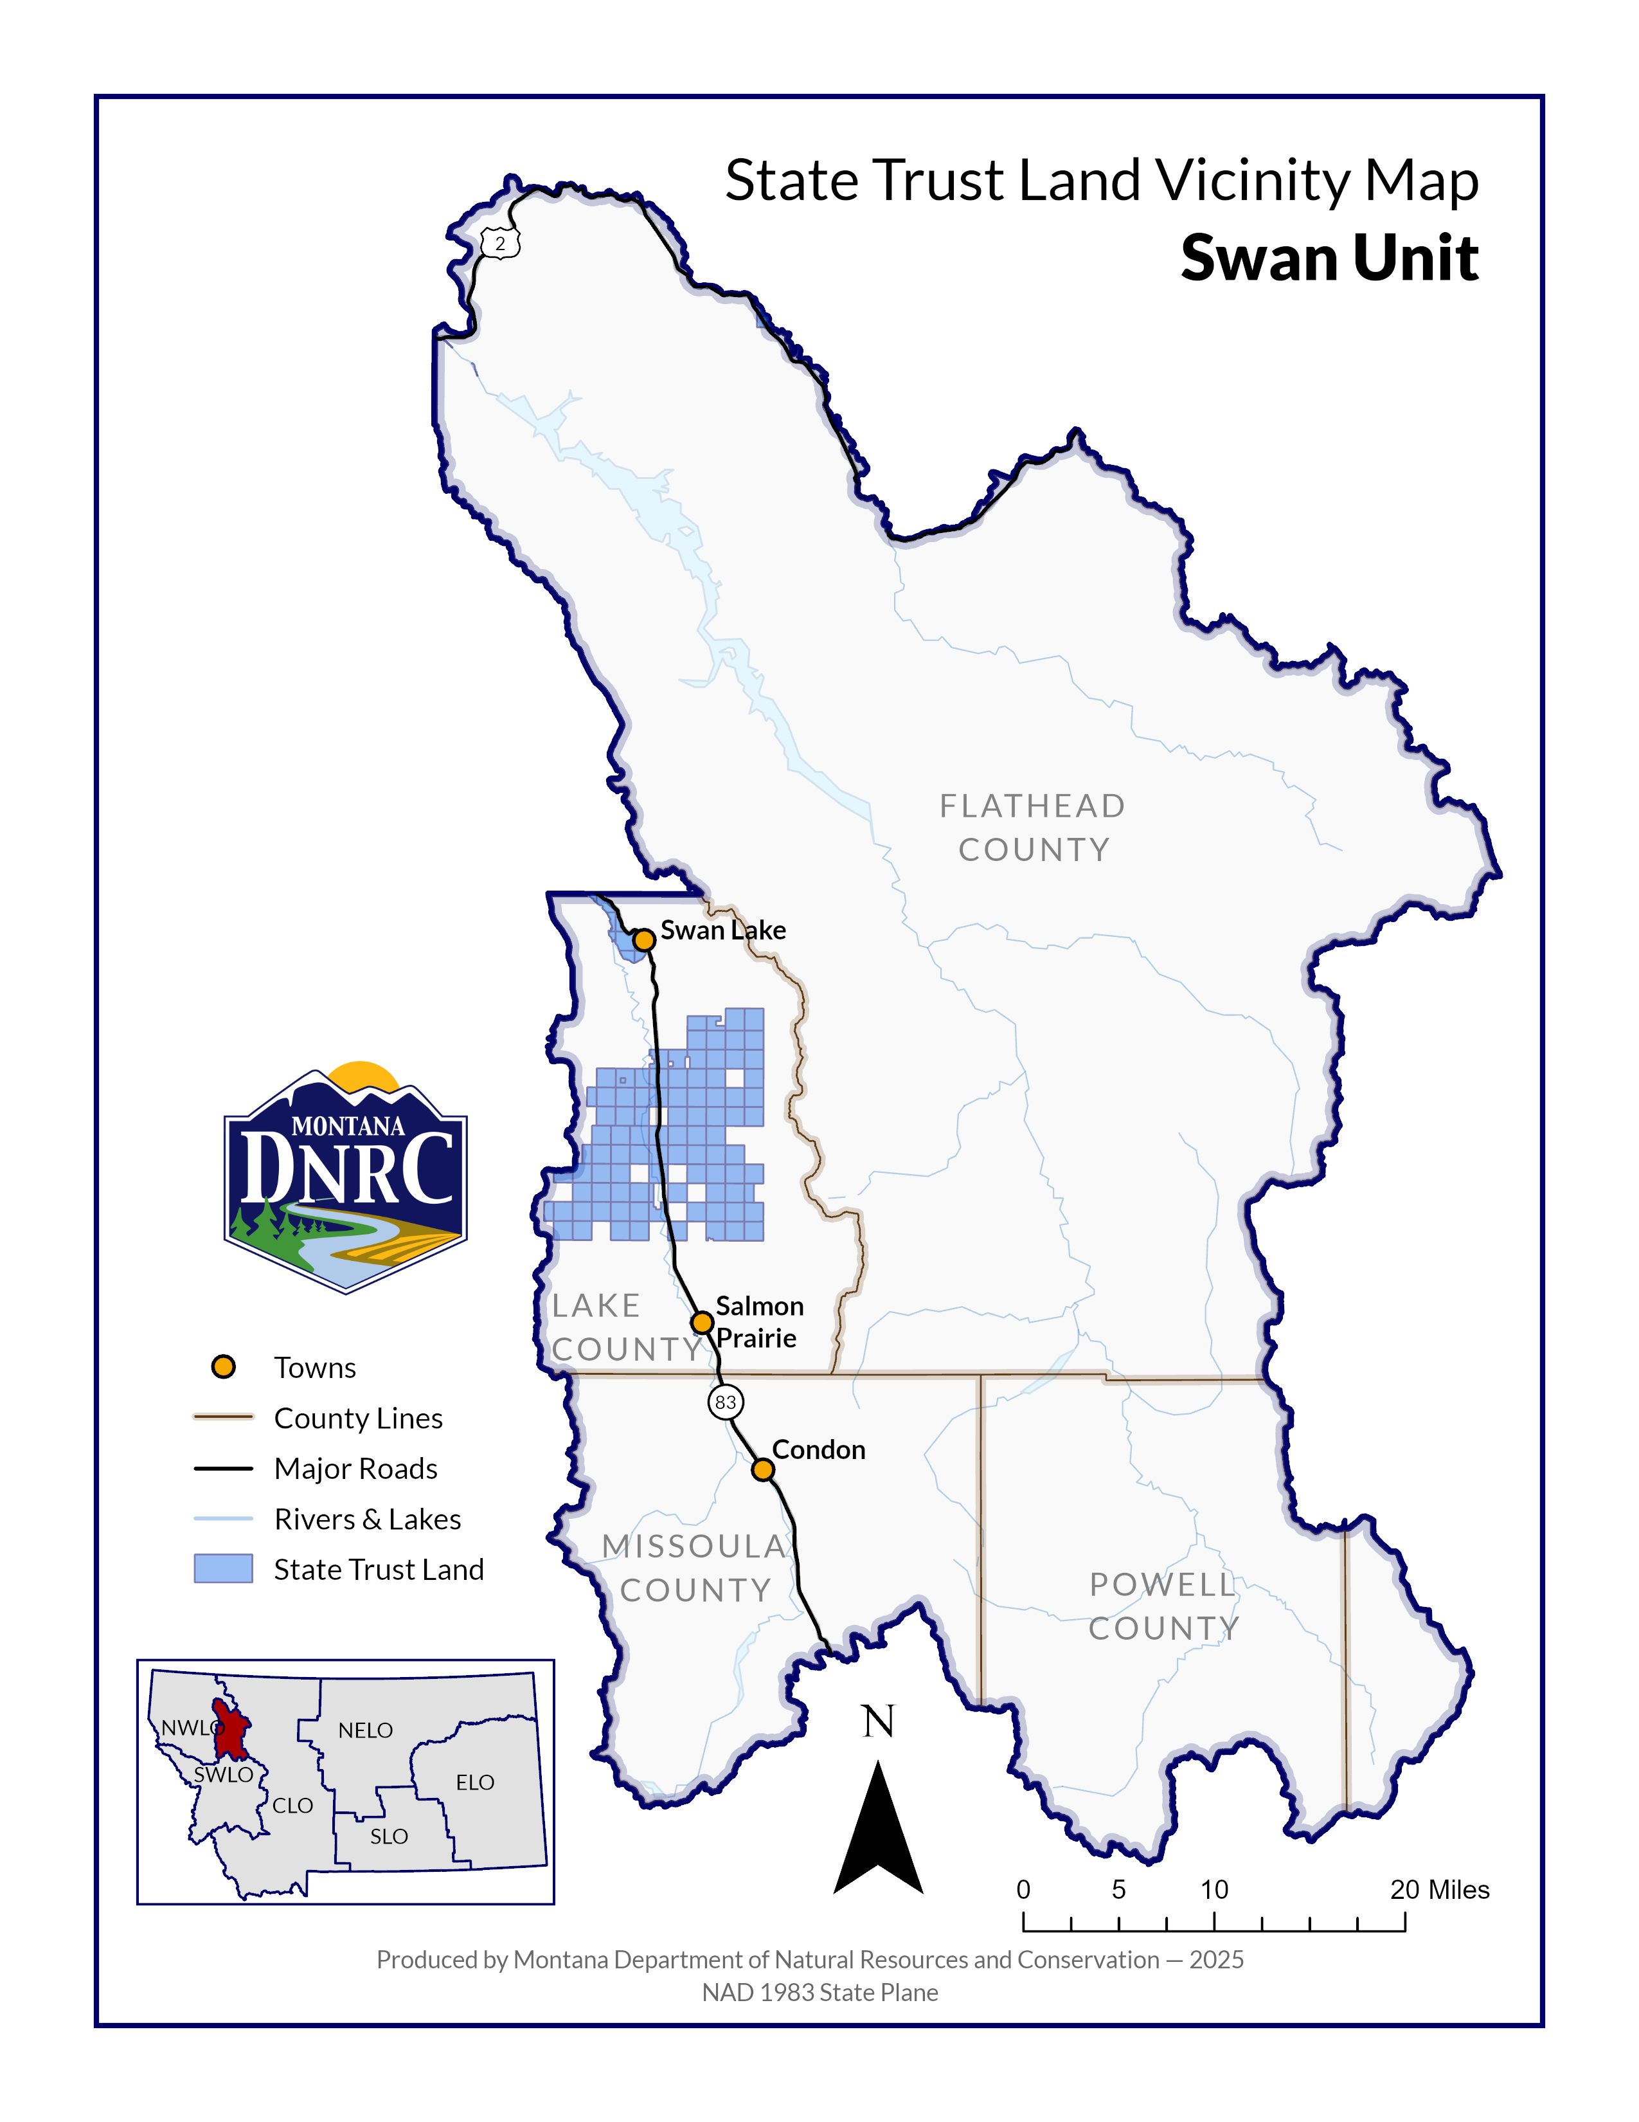`

**Sections: 3, 4, 5, 7, 8, 9, & 10**

**Township: 23N**

**Range: 17W**

**County: Lake**

*In-pa-ah Timber Sale*

*(name is of Salish Tribal origin meaning “Burned Over Ground”*