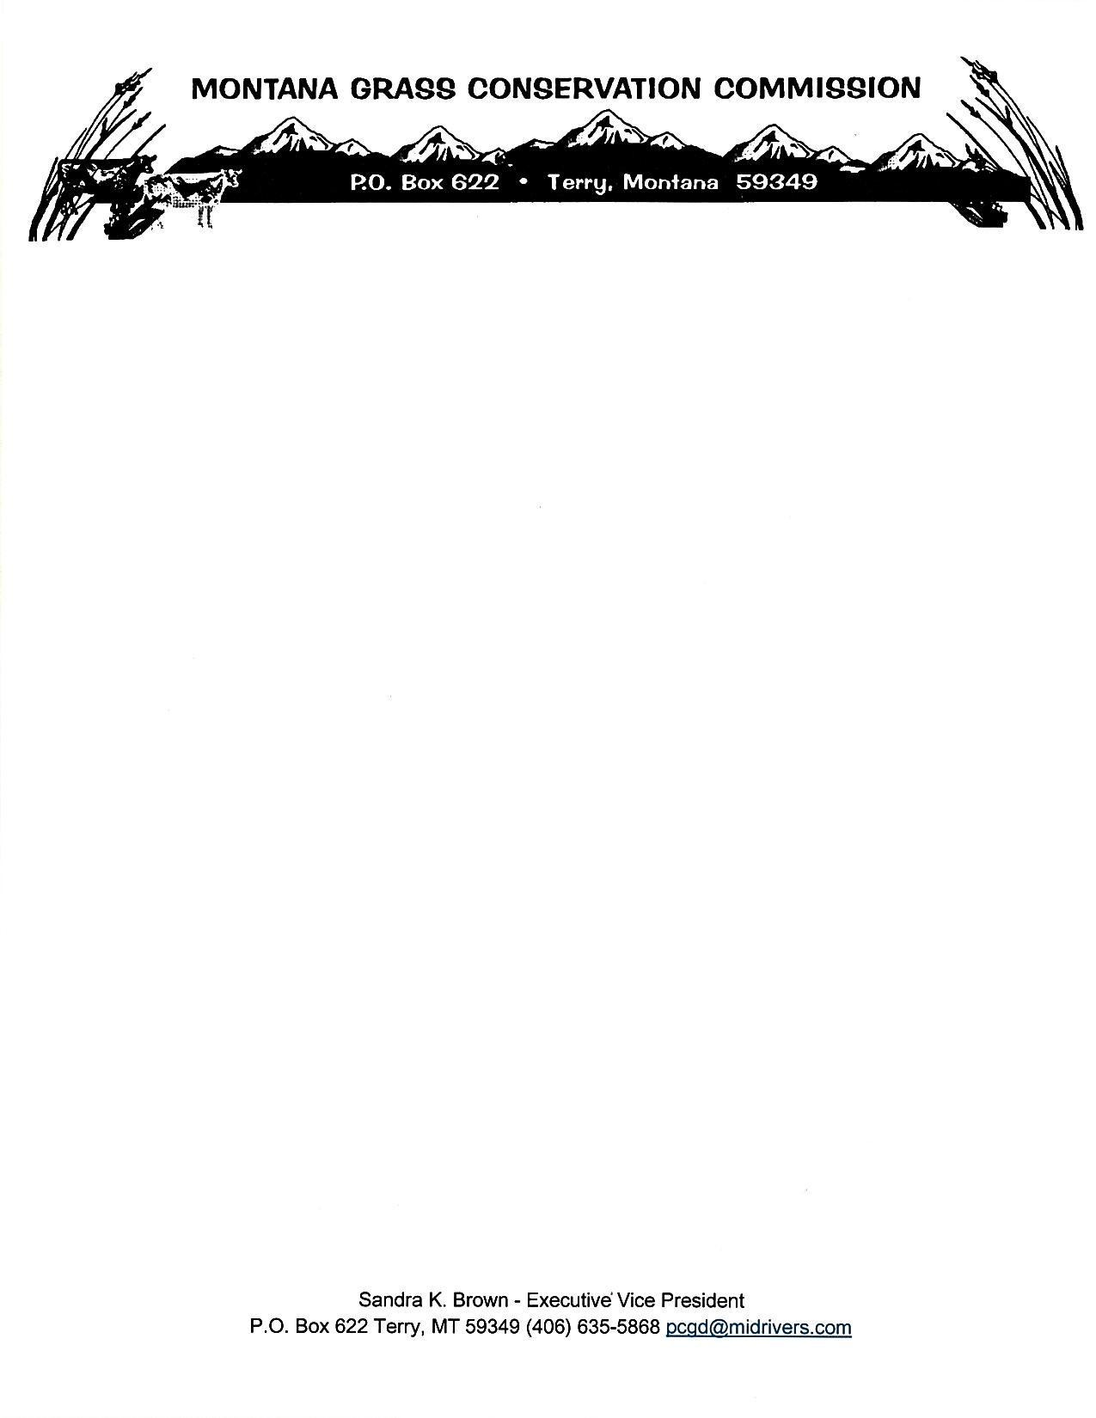

**Montana Grass Conservation Commission**

**Zoom Meeting Agenda**

**December 23rd, 2024 8:00 a.m. – 9:30 a.m.**

**Call to Order – Chairman, Richard Stuker**

1. Minutes from Montana Grass Conservation Commission previous meeting on December 10th, 2024, Zoom. – Action Item **Public Comment**
2. RFP Evaluation and Approval – Action Item **Public Comment**
3. Public Comment or any other business that comes before the Montana Grass Conservation Commission Board