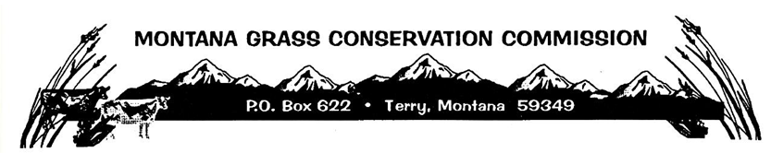

Join Zoom Meeting
https://mt-gov.zoom.us/j/89703322380?pwd=nOJ88Y8UoguvABPV5vv5pdUkpn8BiN.1
Meeting ID: 897 0332 2380
Password: 314140
Dial by Telephone
+1 646 558 8656
Meeting ID: 897 0332 2380
Password: 314140
Find your local number: https://mt-gov.zoom.us/u/kbcpyNih2g
Join by SIP
89703322380@zoomcrc.com
Join by H.323 (Polycom)
162.255.37.11##89703322380

